Roles

Roles act like a set of privileged permissions for any particular user. The roles module is used to bind the user and feature relation. It`s like a user can have many roles and a role can have many features. Roles define the user class. Generally roles are used to differentiate the employees depending on the level of the power they have in their duty. Roles combine a group of features and with which we can assign them to any user.

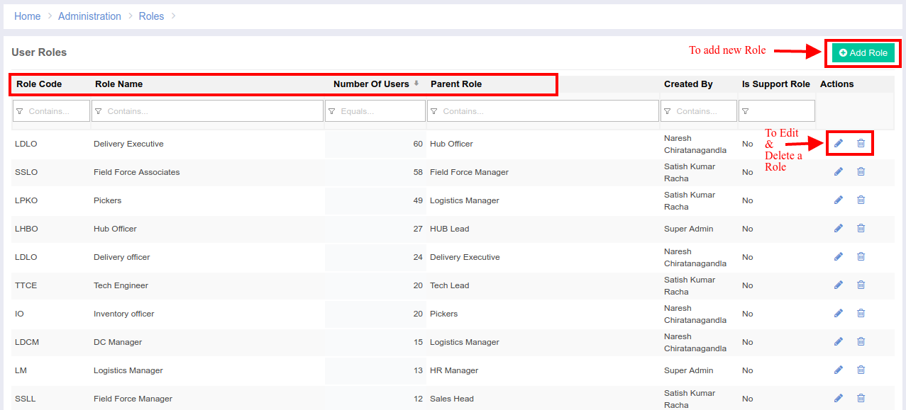

Add/Edit a Role Page (1st Tab)  
-> We need to provide basic details to create Role

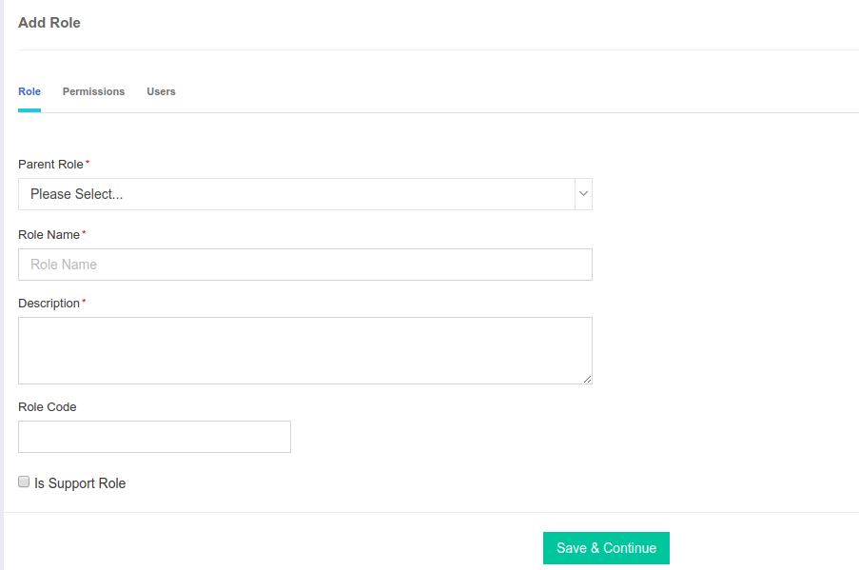

Add/Edit a Role Page (2nd Tab)

-> To assign all the features for the newly created role  
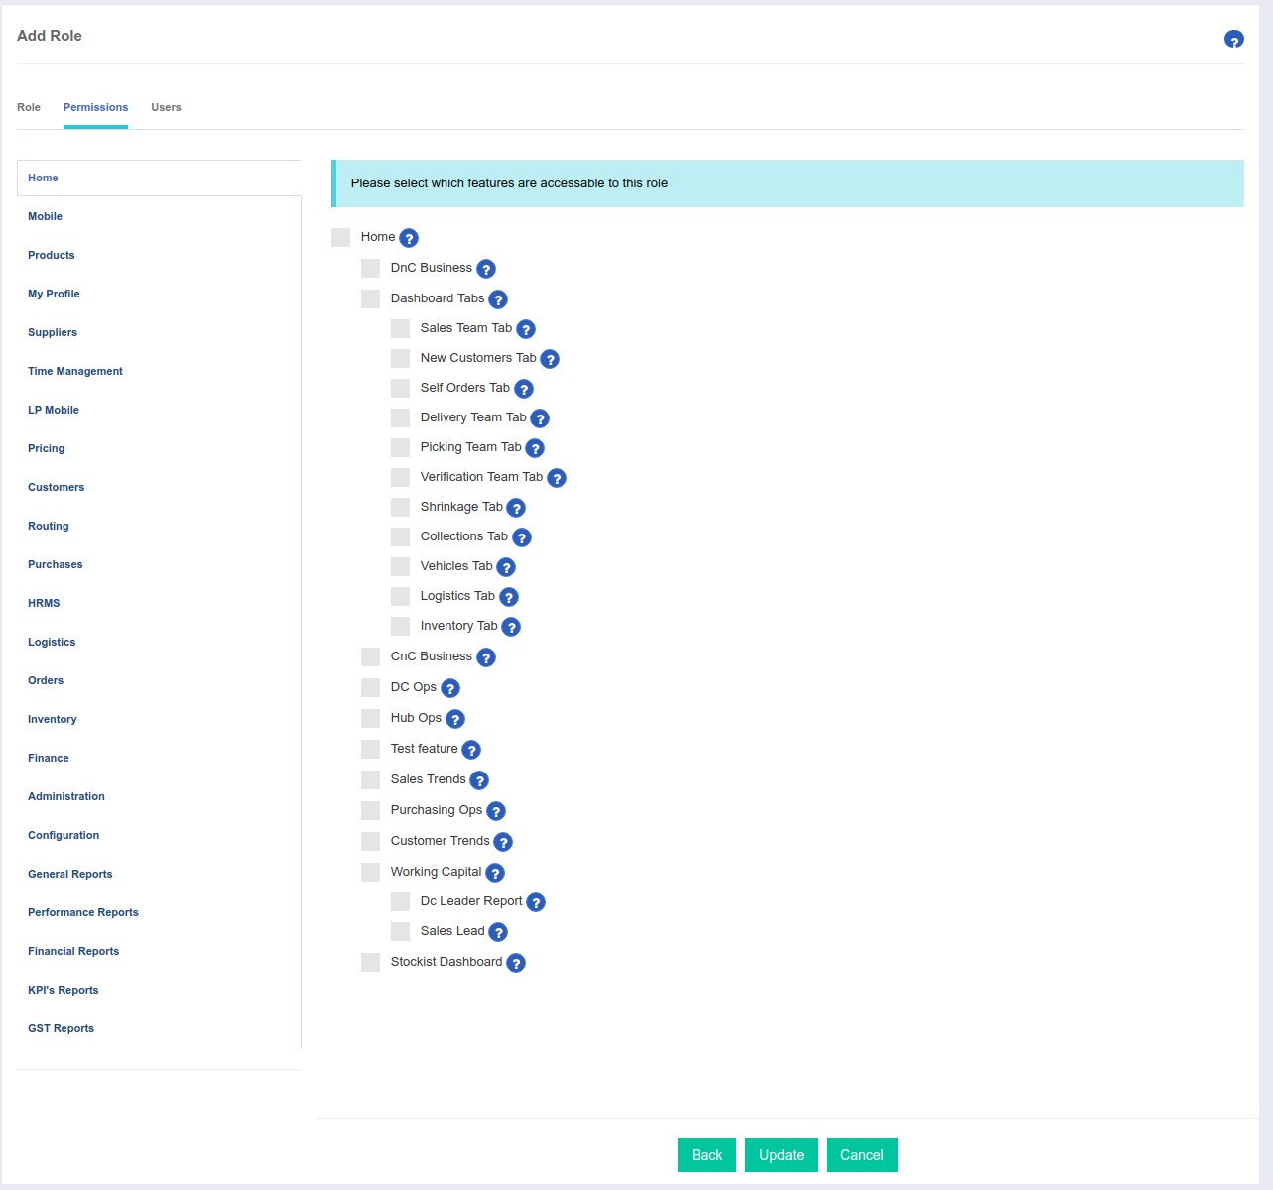

Add/Edit a Role Page (3rd Tab)  
-> To add users to the newly created role

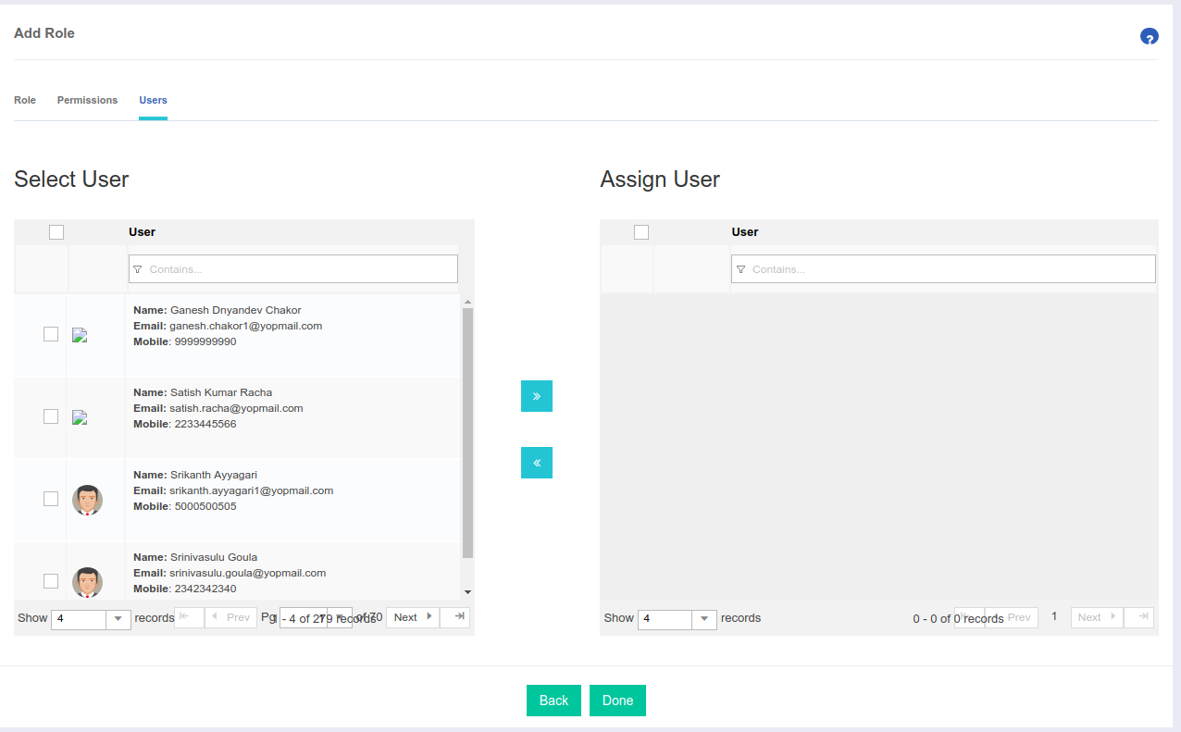  
  
**Code Details:**  
 Url: <http://portal.ebutor.com/roles/index>  
 Module: Roles  
 Database: **roles** table and other tables like **users**, **features**, **role_access** and **user_roles**  
 Features:  
 Add New Role Permission [RLE002]

Edit Old Role Permission [RLE003]

Delete Role Permission [RLE004]

Add New Feature Permission [FRE002]  
 Edit Old Feature Permission [FRE003]  
 Delete Feature Permission [FRE003]

**Code Flow:** When the index page loads, it hits the **getRoles()** method. There, we check the access level and depending on that, we will display the roles which are under him. For every role, we will count the number of users assigned that role and will display them in the UI grid.  
 When we try to add or edit any role, then there are three tabs in a order.

1st Tab: (**Role**) Here, we enter basic details like parent role, role name, role code and to check “is support role” option, we need to click “*save and continue*” button to proceed to next tab in the add new role session.

2nd Tab: (**Permissions**) Here, we need to assign all the features to the role which is created or edited. The structure and sort order of the roles are based on the ui in the features module

3rd Tab: (**Users**) Here, we will assign the users for that role and the users can be filtered based on the user name, email-id and mobile-no.